Personal Loan Backend walkthrough

- App-common
- Pl-account-verification-service
- Pl-customer-prefilldata-service
- Pl-customer-service
- Pl-kyc-verification-service
- Pl-loan-disbursal-service
- Pl-loan-generation-service
- Pl-rewards
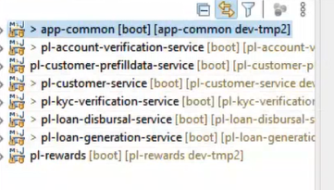

Common-service-controller
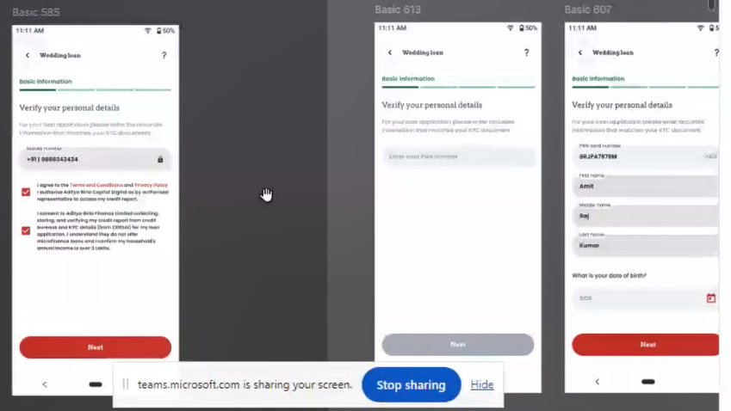

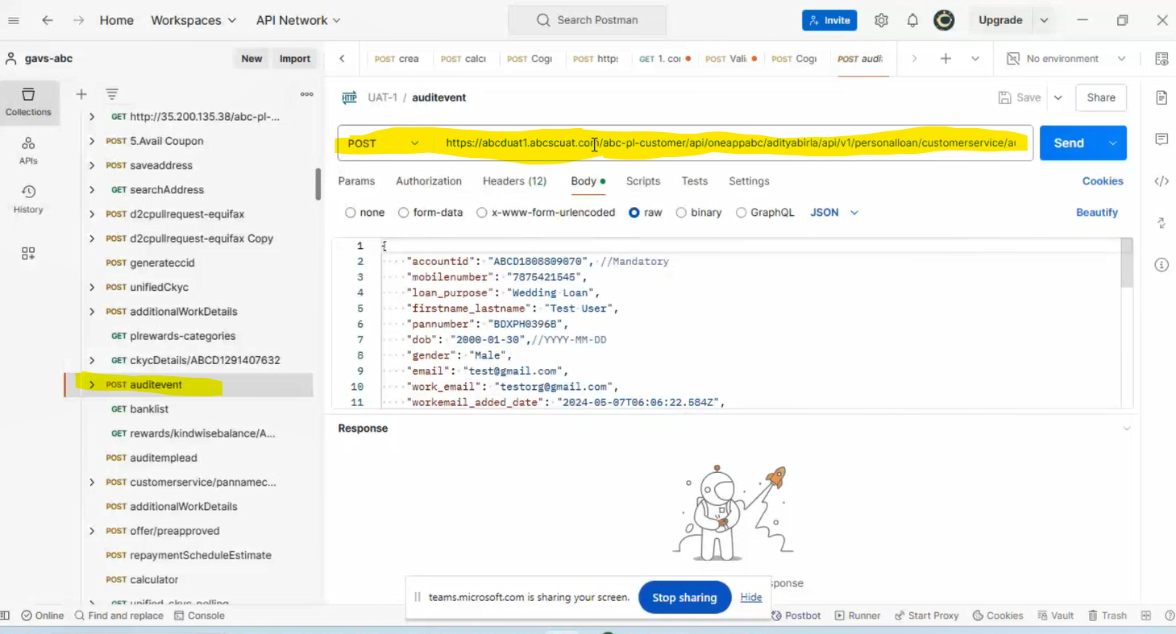

Pantodob api:

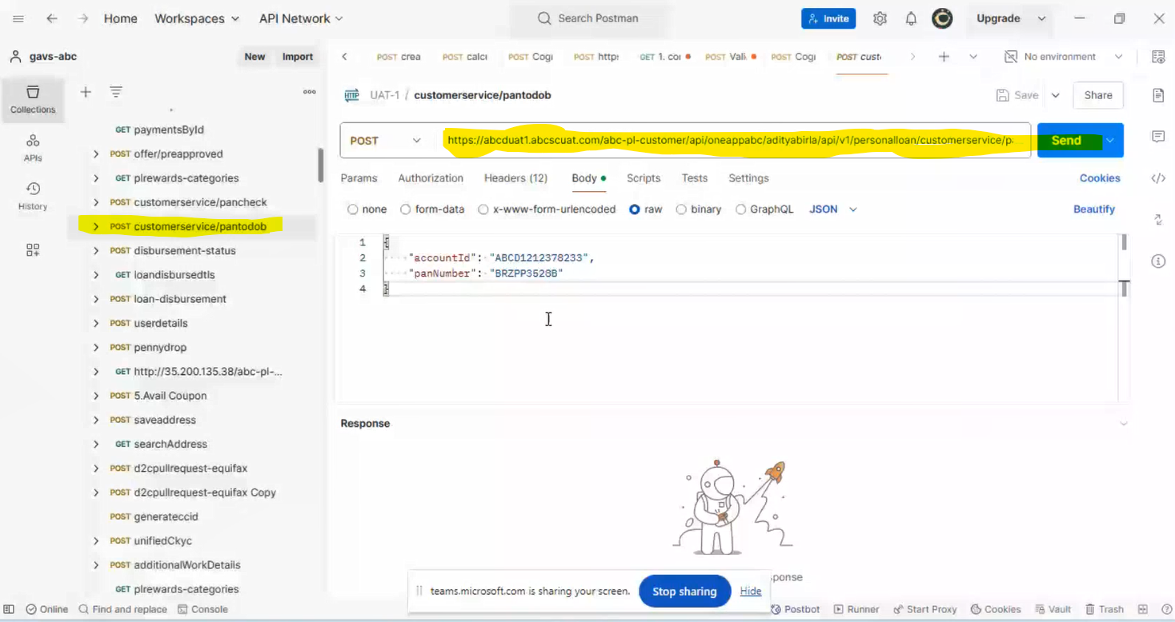
Pantodob front UI:
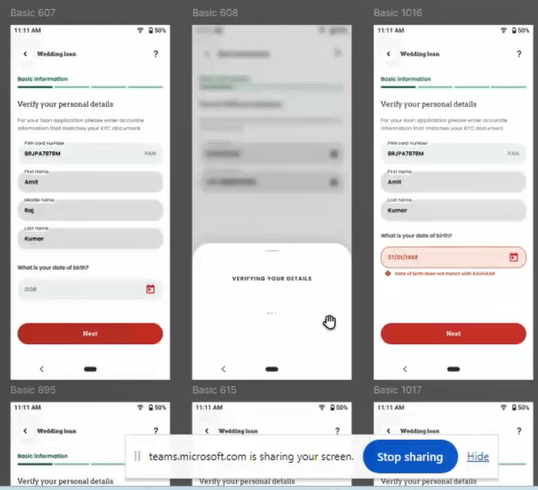

Generateccid API
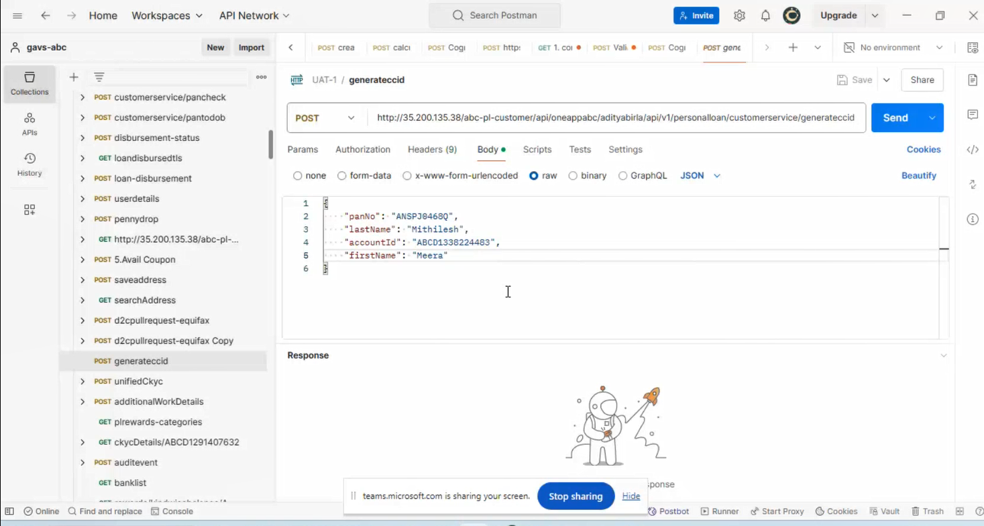

UI to call the decision engine.
